File Creation Task

Task 1:
- Create the directory
# mkdir my_folder
- Navigate into it
# cd my_folder
- Create a file with some text
# echo "This is the content of my_file.txt." > my_file.txt
- Create another file with some text
# echo "This is the content of another_file.txt." > another_file.txt
- Concatenate another_file.txt to my_file.txt
# cat another_file.txt >> my_file.txt
- Display the updated content of my_file.txt
# cat my_file.txt
- List all files and directories in the current directory
# ls -la
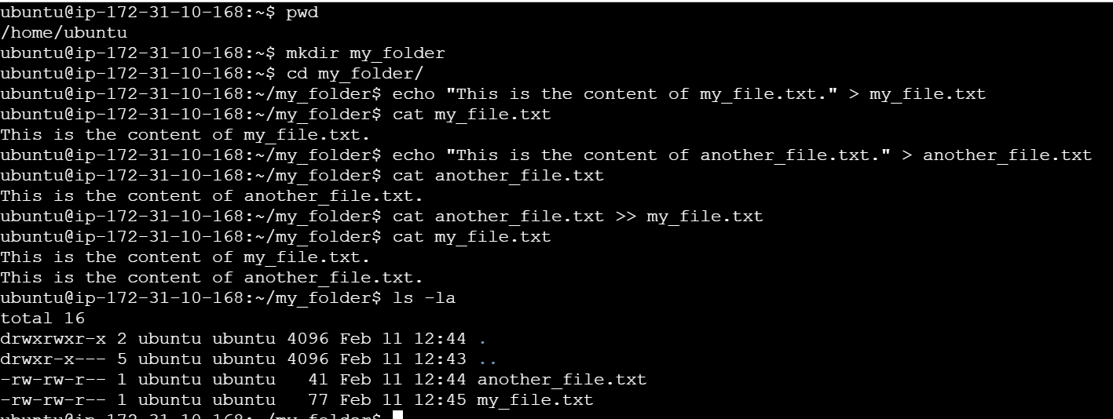

Task 2:
- Create 20 .txt files
# for i in {1..20}; do touch "file$i.txt" ; done
for i in {1..20} : This part creates a loop that iterates over the 20 files.
do ... done: This defines the actions to be performed within the loop for each file.
touch "file$i.txt" : Creates 20 .txt files.
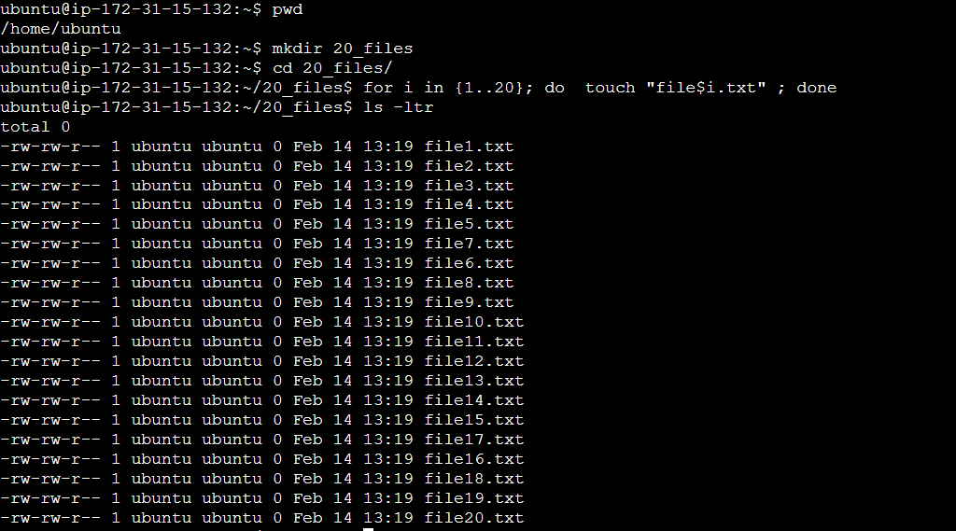

2. Rename the first 5 files to .yml extension
# for i in {1..5};do mv "file$i.txt" "file$i.yml";done
for i in {1..5} : This part creates a loop that iterates over the first 5 files.
do ... done: This defines the actions to be performed within the loop for each file.
mv: The mv command is used to move/rename the current file in the loop.
mv "file$i.txt" "file$i.yml" : Rename the first 5 files to .yml

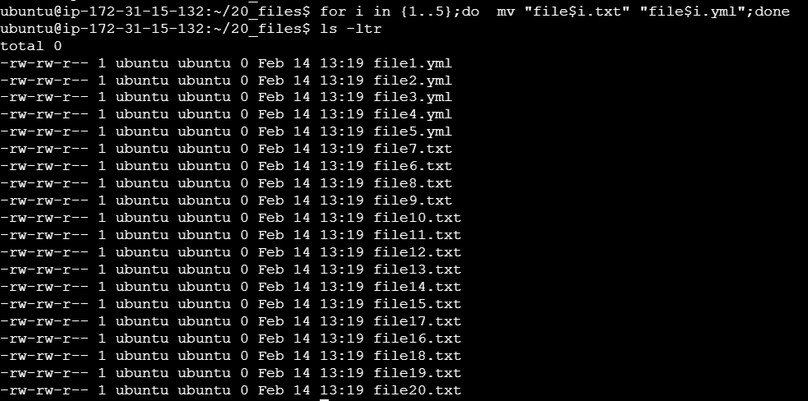
3. Print the latest created top 5 files
# ls -tr| head -n 5
ls -tr -> sorts files by newest first
head -n 5 -> prints only the first 5 files listed by ls command.
